Question: How can the buying habits of 45–55-year-olds improve profits for the Company?
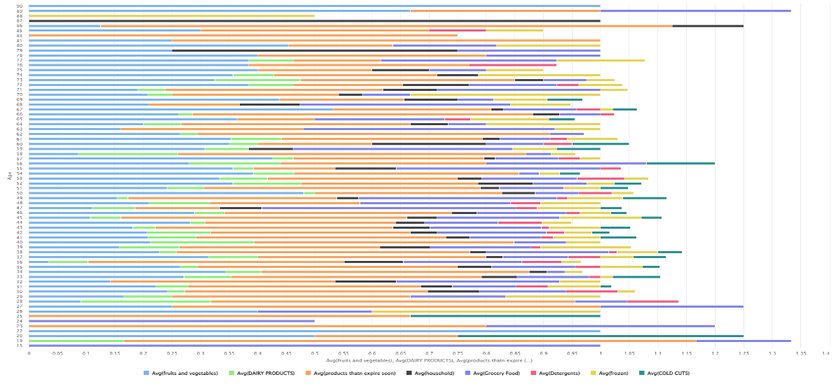
Fig 1: Buying Habitats of Customers Based on Age
Based on the bar chart present in Fig. 1, it is clear the age group of 45-55 years demonstrates distinct and diverse purchasing patterns compared to younger age groups. On average, individuals in this age group tend to buy more dairy products, items that expire soon, grocery foods, detergents, and cold cuts. While the purchasing behaviour of fruits and vegetables, frozen foods, and household products are fractionally lower than those present in the 35-45 year-old group. These trends suggest a more routine oriented shopping style focused on the essentials and perishable goods.​
Based on the buying habits of 45-55-year-olds, a focused business action plan can significantly boost company profits. The introduction of targeted bundle deals such as pairing items that expire soon with staple goods like milk, bread or eggs at a discount between three to four percent, which can reduce waste and increase basket size. Additionally, running a back-to-school campaign that focus on fruits and vegetables, and household essentials may encourage increased interest in categories where 45-55 year-olds currently have on average a lower spend. Implementing a loyalty driven “saver scheme,” where shoppers receive a discount for reaching specific basket values, can further incentivize larger basket value and lead to a higher frequency in customers returning to the company.​
Adopting these strategies aligns product offerings and promotions closely with the needs and preferences of 45-55 year-olds, ultimately driving higher sales and reducing product waste within this valuable customer segment.​

